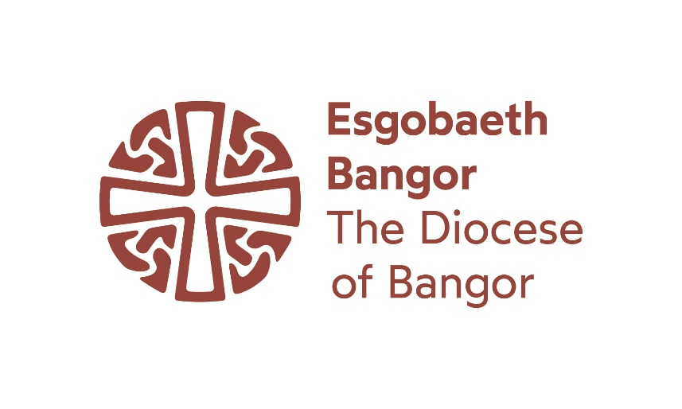
Ministry Area Leader and Vicar for Bro Celynnin, Diocese of Bangor

https://caruconwy.com/

We serve Conwy Town and Valley; we are flourishing, united and hopeful; we seek a visionary, spiritually gifted and loving priest to lead us, so that together we can:
- Focus on evangelism and growth, especially among young people and families
- Deepen discipleship and prayer, encourage gifts and foster new vocations
- Deliver and manage complex projects, including the renewal of Medieval buildings
- Work collaboratively with colleagues and volunteers to build healthy teams
- Partner with our two church primary schools, secondary school, churches and community
- Encourage a rich, diverse and inclusive life of gathered congregations, online ministry and Fresh Expressions ‘beyond the walls of church’
- Encourage many forms of creative worship, including our tradition of liturgical music
- Provide excellent preaching, engaging teaching and effective communication
- Be fully bilingual (or committed to learning Welsh) to reflect our Mission context
- Continue our commitment to the full participation of Deaf and disabled people
- Help each other to sustain a demanding rural ministry with wisdom and humour through the hospitality of our communities and church family – and taking proper rest

Bro Celynnin Ministry Area was formed in 2016 as a single united benefice with one Ministry Area Council (‘PCC’) from the four previous parishes of Conwy, Gyffin, Caerhun with Llangelynnin, and Llanbedr-y-Cennin. Celynnin was a 6th Century saint who baptised alongside a mountain drovers’ road, at the holy well where the Hen Eglwys, Llangelynnin was later built.

We are bounded on the north by the sea and the town of Conwy, on the east by the Conwy river, and on the west by the Carneddau range and Eryri (Snowdonia) National Park - extending south in the Conwy Valley to Tal-y-Bont. The resident population is about 7,000 but thousands of tourists also visit each year. Most employment is in the public sector, tourism accommodation and services, agriculture or retail. A small fishery still operates from Conwy Quay. Thanks to the proximity of the A55 and mainline railway many residents commute to other areas for work.
The main centre of population is Conwy, with the adjacent village of Gyffin. The medieval town is one of the jewels of North Wales and a UNESCO World Heritage Site. Set against the backdrop of the Carneddau mountain range, and at the mouth of the River Conwy, its impressive harbour, castle and complete circuit of town walls, built by Edward 1 in the 13th century, make it one of the UK’s most popular destinations. Its population at the last census was 5161. The town Primary School (Ysgol Porth y Felin) is a Church in Wales Voluntary Controlled School with over 300 pupils, whilst the Secondary (Ysgol Aberconwy), which serves a wider geographical area, has about 800 pupils.
In the rural area to the south lie smaller villages, notably Henryd (where our fully Welsh medium Church Primary, Ysgol Llangelynnin has 90 pupils), Ty’n-y-Groes, Rowen, Tal-y-Bont and Llanbedr-y-Cennin. Though sought after for second homes and retirement, we are still a farming and rural community with active groups and a strong local sense of identity. A significant minority of the population prefer to communicate in Welsh (and all children in Wales are taught bilingually). The MA cares for five much-loved medieval churches (four of them Grade I Listed) and seven churchyards. It has developed Fresh Expressions, online and community ministries.
St Mary’s, Conwy
Founded in about 1190, the Cistercian Abbey of Aberconwy was strongly associated with Llewelyn Fawr and the Princes of Gwynedd. Edward I cemented his conquest by building the castle and walled town around it but St Mary’s continued as a place of prayer and Christian witness. Now at the centre of the town, it is recognised as one of the most significant heritage buildings in Wales. The St. Mary’s 11am Sunday service, mostly Eucharistic with a choir, is interpreted in Sign Language once a month. There are large Civic Services and packed congregations for set-piece occasions like Nine Lessons and Carols or funerals of well-known community figures.
Numbers on a more usual Sunday have begun to recover after the Pandemic and there are always visitors. St Mary’s has a proud musical tradition, fostered over many years by the Director of Music, who began his musical career here as a chorister. A Ministry Area choir Cantorion Celynnin has been established which has contributed to broadcasts on the BBC, Radio Cymru and S4C, leads the re-established monthly evensong and sometimes assists at Bangor cathedral. We also have a junior choir, Canu Conwy. St Mary’s sustains a week-long annual Festival of Classical Music. It attracts huge and appreciative audiences to concerts given by performers ranging from those with an international reputation to those taking the first steps of their professional careers.

Despite its lack of toilets and other basic facilities, St Mary’s receives more than 21,000 visitors each year. We have developed a large, positive and diverse team of welcome volunteers who provide daily opening for 7 or 8 months of the year. We have also put on, or been the venue, for all kinds of Arts, Music and Theatre Events, including immersive light installations, the Conwy Council Creu Conwy Winter Sounds Festival, children’s workshops and adult education classes.
The Studio collective of artists, linked to Bro Celynnin, hold regular exhibitions in St Mary’s and our other church buildings, often inspired by the themes we have explored in worship. We are now recognised as a significant part of the cultural life of our region, with real potential to do more, but also face big financial challenges if we are to repair and equip this important building.

St Benedict’s, Gyffin
Almost certainly a site originally dedicated to a Celtic Saint, St Benedict’s lies outside the pale and boundary stream (in Welsh, ‘Y Gyffin’) of Edward’s fortified colonial English town. It is a hidden Medieval gem, with painted 14th Century chancel ceiling and the cosy feel of an ancient parish church. From October until March, a large and eclectic monthly congregation gathers for candle-lit contemporary Celtic worship (many of whom would attend Llangelynnin in the summer). Having ceased to have a weekly Sunday service in Gyffin during the Pandemic, we planted a new mid-week congregation there. It has grown into a thriving and prayerful community who are excited by the imminent reordering of St Benedicts’s to provide more flexible space and facilities for hospitality: not least a long-awaited lavatory!

St Mary’s, Caerhun
Set in a tranquil bend of the River Conwy on the site of a former Roman Fort, St Mary’s is surrounded by sheep fields and hills. It retains much of the simplicity and order of the Cistercian founders and its peaceful beauty speaks to many. In recent years we have delivered a successful project to transform a ruined outbuilding into a composting toilet and storeroom, added mesh to a parking field and installed a sound system.
This helps the faithful congregation to welcome weddings and baptism families and to put on other events such as a biodiversity churchyard day and a creative retelling of the Mabinogion. Options are being considered to create better disabled access and more flexible space in the church building but first there is an aspiration for us to employ a community development worker locally.

St Peter’s, Llanbedr-y-Cennin
St Peter’s Church is a classic country church, opposite the village pub. The small, lively congregation mostly walk to worship and know their neighbours well. St Peter’s has held flower festivals and provided refreshments for local open garden events. Perhaps because Cennin Pedr means daffodil, it is always the setting for our celebration of Dydd Gŵyl Dewi (St David’s Day). Inclusive, generous and fun, St Peter’s sustains a tradition of hospitality and small group Bible study. It has a deep sense of the local history it embodies. We are delighted that Bro Celynnin has established a shared sense of belonging, friendship and working together without sacrificing the importance of remaining distinctive and local. St Peter’s exemplifies the value of that balance.

Llangelynnin and Celtic Praise
St Celynnin’s Church sits in the foothills of the Carneddau, southwest of Henryd, in a spectacular location. Its rugged simplicity and the sweeping views make it a favourite stop on the Pilgrim’s Way to Ynys Enlli (Bardsey Island) and many local walks. In the corner of the walled churchyard is a holy well associated with 6th century Saint Celynnin. The church interior is unadorned, apart from some important medieval wall inscriptions and simple furniture. Here there is no electricity or modern facilities, adding to the sense of having discovered somewhere remote, vulnerable and special. Llangelynnin is on the cover of ‘Britain’s Holiest Places’, regarded by many as a ‘thin place’ resonant with the presence of God.
Over the last seven years, a pattern of bilingual, reflective worship in a Celtic style has developed, led by an acoustic group of musicians. It draws people from far and wide, from different denominations and world views or those searching for faith. The ‘Llangelynnin season’ begins with sunrise communion on Easter Day, a large congregation some of whom walk or run there in the dark. Then there are monthly services until October, each ending with hospitality in a local smallholding (at least one service held outdoors, to include the blessing of horses).

Worship in the Wild
What started with Pandemic Lockdown prayer walks has grown into a broad network of people who find meaning and new relationships in the landscape of North Wales. In those three years we have never repeated a walk, such is our abundant choice. Each walk is split into sections, interspersed with interactive ‘ponder spots’, reflecting on the character and history of each setting in the light of Christian Faith and our life experience. We believe God is the third person in what are often pastoral and healing conversations or in stillness (we always incorporate some time of silence). This year we were delighted to receive grant funding for seven people to complete the Mountain Training Association’s ‘Lowland Leader’ Training and Outdoor First Aid. This placed ‘Worship in the Wild’ on a safer and more secure footing, as well as modelling co-leadership (vital as new people are added to our mailing list every month). The start time depends on the length of walk and location but is sometimes a Sunday morning. It is therefore offered as a legitimate act of worship, alongside more traditional services and can often attract those who would not attend church buildings.

Online Ministry
Throughout the Pandemic lockdowns we produced daily emails, with more than 60 people contributing reflections and prayers. This grew into a ministry of regular video messages and online services, still continued in a weekly Zoom Group and our social media output. The Carolau Conwy Advent daily series with different community members and carols in Welsh and English brought us new connections all over the world, including a joint online Lent Group with a church in Canada. It has been striking how many people will engage with and be inspired by a simple message of hope and it has made us aware of a far greater set of relationships than those visible face to face.

Keeping in Touch Letters
Each month a message with news, reflection and prayers is delivered by hand or email, particularly to those no longer able to attend worship. It has often been combined with gifts of flowers or handmade cards, pastoral ‘phone calls or home communion and is hugely appreciated.

Life groups
These were relaunched in Autumn 2023 and focus on living life together in the light of God’s Kingdom. They aim to be safe places for everyone to be supported in discovering faith and growing in their relationship with God. Already four groups are underway in homes or church buildings, with a fifth on zoom, and have brought together a wide range of people.

Bagiau Cariad / Bags of Love
Our food poverty project delivers 100 monthly hampers, mainly for families with children at local schools. We started during the Pandemic and are now a team of over 40 volunteers drawn from all our congregations, other churches and the local community. There is a lot of social need, especially among people working for low pay or whose lives have been disrupted by setbacks. School children also help every fortnight to deliver food to pensioners in a local day centre. An extensive network of committed people and local businesses support us with food or financial donations; we also helped a neighbouring parish to start a similar scheme for their communities.

Church Hall
As well as being the base for ‘Bagiau Cariad’, our Hall is a significant community hub. We have hosted vaccinations, public meetings & consultations, arts events, clubs, groups and the town orchestra. We put on harvest suppers, coffee mornings and afternoon teas, church meetings and study groups, contemporary micro-gigs, choirs and children’s work. Despite all this (and an enviable location in the centre of Conwy) there is a need for investment and repair. This is being addressed through a potential partnership with the diocese and wider Church in Wales, plus a current funding bid, which also hopes to bring back into use a derelict former school playground.

Bro Celynnin Ministry Team
We currently have a Pioneer Priest (shared with another MA), NSM Priest, Lay Reader, a Lay Reader in training, three active retired priests, a newly commissioned team of Lay Worship Leaders and a part-time administrator. With the support of our Area Dean and the wider diocese, they have enabled our Ministry Area Wardens, local Churchwardens, Ministry Area Council and everyone involved in Bro Celynnin to remain outward-looking and grow in faith. We try to serve our communities faithfully and to keep seeing God ‘Changing Lives with Love.’ We are really excited to welcome a new Ministry Area Leader and Vicar - and to enter a new season together.

