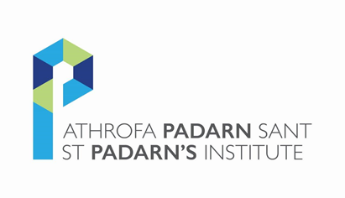

Lay Reader Conference 2020, Swansea Bay

Friday, 3rd July – Sunday, 5th July 2020

Booking Form
Title |  | First Name |  | Last Name

Diocese

Address

Telephone Number

Email Address

Dietary Requirements

Other Requirements
I will require accommodation for the duration of the conference |  |  |  |  | Yes |  |  | No
May St Padarn’s use your image for promotional and educational purposes through print, social media and web? |  |  |  |  | Yes |  |  | No
St Padarn’s Institute would like to send you occasional news and training opportunities via email. To join our mailing list, simple tick the box to the right. ☐
You can unsubscribe at any time. For information on how we look after your data, please see https://www.churchinwales.org.uk/privacy-notice/
Please return this form by the 13th March to CMD Admin at
Email: cmdadmin@stpadarns.ac.uk or via
CMD Admin, St Padarn’s Institute, 54 Cardiff Road, Llandaff, Cardiff CF5 2YJ

Cynhadledd Darllenwyr Lleyg 2020, Bae Abertawe

Dydd Gwener, 3 Gorffennaf – Dydd Sul, 5 Gorffennaf 2020

Booking Form
Teitl |  | Enw Cyntaf |  | Cyfenw

Esgobaeth

Cyfeiriad

Rhif Ffôn

Cyfeiriad E-bost

Anghenion Dietegol

Gofynion eraill
Byddaf angen llety ar gyfer y gynhadledd gyfan |  |  |  |  | Byddaf |  |  | Ni fyddaf
A all Padarn Sant ddefnyddio eich llun ar gyfer unrhyw ddeunydd hyrwyddo neu addysgiadol drwy brint, ar dudalennau cymdeithasol neu ar ein gwefan? |  |  |  |  | Gallwch |  |  |  | Na
Hoffai Athrofa Padarn Sant anfon newyddion a chyfleoedd hyfforddiant atoch yn achlysurol drwy e-bost. I ymuno a’n rhestr llythyru cliciwch y blwch ar y dde ☐
Gallwch ddod a'ch tanysgrifiad i ben ar unrhyw adeg. Am fwy o wybodaeth ar sut rydym yn goflau am eich data ewch at: <https://www.churchinwales.org.uk/privacy-notice/>
Dychwelwch y ffurflen i CMD Admin erbyn 13 Mawrth drwy ei hanfon at
Email: cmdadmin@stpadarns.ac.uk neu ei bostio at
CMD Admin, St Padarn’s Institute, 54 Cardiff Road, Llandaff, Cardiff CF5 2YJ

